Alabama
Montgomery Zoo, Montgomery

Arizona
Heritage Park Zoo, Prescott
Navajo Nation, Window Rock
SEALIFE Arizona Aquarium, Tempe

Arkansas
Little Rock Zoo, Little Rock
California
EFBC Feline Conservation Center, Rosamond
California Living Museum, Bakersfield
Folsom City Zoo Sanctuary, Folsom
Happy Hallow Park & Zoo, San Jose
Los Angeles Zoo, Los Angeles
Santa Ana Zoo, Santa Ana
Big Bear Alpine Zoo, Big Bear City
Charles Paddock Zoo, Atascadero
Gibbon Conservation Center, Santa Clarita
Carbrillo Marine Aquarium, San Pedro
DC
Smithsonian’s National Zoological Park (Washington)**

Florida
Flamingo Gardens, Davie
Clearwater Marine Aquarium, Clearwater
The Florida Aquarium, Tampa

georgia
Chehaw Park and Zoo, Albany
Hawaii
Pana’ewa Rainforest Zoo, Hilo
Waikiki Aquarium, Honolulu
Maui Ocean Center
Idaho
Zoo Idaho, Pocatello

Illinois
Cosley Zoo, Wheaton
Phillips Park Zoo, Aurora
Henson Robinson Zoo, Springfield
Lincoln Park Zoo, Chicago
Summerfield Zoo, Rockford

Indiana
Columbian Park Zoo, Lafayette

Kansas
David Traylor Zoo, Emporia
Hutchinson Zoo, Hutchinson
Ralph Mitchell Zoo, Independence
Lee Richardson Zoo, Garden City
Great Bend Brit Spaugh Zoo, Great Bend
Wright Park Zoo, Dodge City

Louisiana
Alexandria Zoo, Alexandria
Zoosiana, Broussard
Baton Rouge Zoo

Maryland
Catoctin Wildlife Preserve, Thurmont
Salisbury Zoo, Salisbury

Massachusetts
The Zoo in Forest Park, Springfield

Michigan
SEALife Michigan Aquarium, Auburn Hills

Minnesota
Lake Superior Zoo, Duluth
Minnesota Zoo, Apple Valley
Pine Grove Zoo, Little Falls
Como Park Zoo, St Paul

Mississippi
Jackson Zoo, Jackson

Missouri
Saint Louis Zoo. Saint Louis
SEA LIFE Kansas City Aquarium

MOntana
ZooMontana, Billings

NeBRASKA
Riverside Discovery Center, Scottsbluff

New Jersey
Cape May County Park and Zoo, Cape May
Bergen County Zoological Park
Cohanzick Zoo, Bridgeton

New Mexico
Bio Park- Albuquerque
Alameda Zoo, Alamogordo
Spring River Zoo, Roswell

New York
Binghamton Zoo at Ross Park, Binghamton
Utica Zoo, Utica
New York State Zoo at Thompson Park, Watertown

North Dakota
Chahinkapa Zoo, Wahpeton
Dakota Zoo, Bismarck

Ohio
African Safari Wildlife Park, Port Clinton

OREGON
Wildlife Safari, Windsor

Pennsylvania
Pittsburg Zoo and PPG Aquarium, Pittsburg
Elmwood Park Zoo, Norristown
Erie Zoo, Erie

South Carolina
Greenville Zoo, Greenville

South Dakota
Bramble Park Zoo, Watertown

Tennessee
Bright’s Zoo

Texas
Austin Aquarium, Austin
Ellen Trout Zoo, Lufkin
Rose Exotic Feline Sanctuary, Frierson (free)
San Antonia Aquarium, San Antonia
Gladys Porter Zoo, Brownsville
Amarillo Zoo, Amarillo
Austin Zoo, Austin
Texas Zoo, Victoria

Utah
Zootah at Willow Park, Logan

Virginia
Mill Mountain Zoo, Roanoke

Wisconsin
Henry Vilas Zoo, Madison
Ochsner Park Zoo,Baraboo
Wildwood Zoo, Marshfield
New Zoo, Green Bay

The Washington Park Zoo participates in a shared membership reciprocity program for our members to enjoy discounted or free admission to other zoos and aquariums across the country.

Benefits at each facility vary and may change without notice. Please ALWAYS call ahead to the facility that you are interested in visiting to determine what benefits are still available for Washington Park Zoo Members and what is required to receive those benefits. Some facilities that do not charge admission may offer discounts in their gift shop or towards other attractions

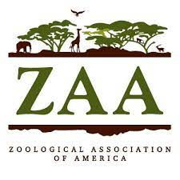

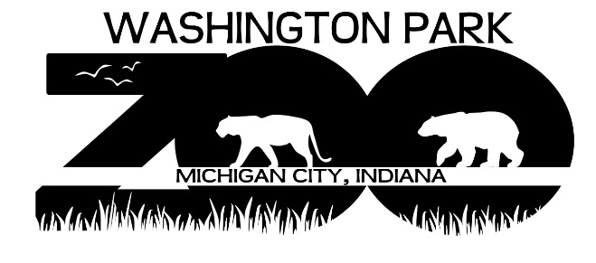

Membership Reciprocal List 2023

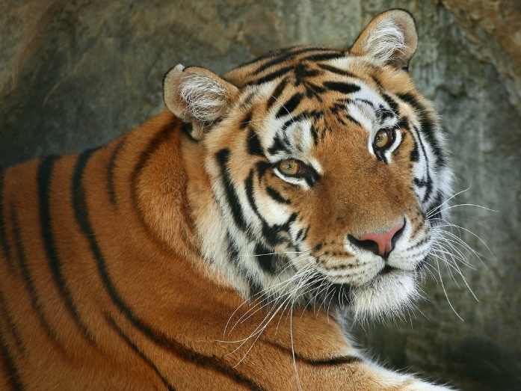
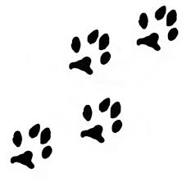

115 Lakeshore Drive,
Michigan City, Indiana 46360

